**=================================== Microservices===================================**

Microservices is an architectural style in which large, complex software applications are composed of one or more smaller services.

Microservices used in the development world as the developers work to create larger, more complex applications that are better developed and managed as a combination of smaller services that work cohesively for larger application-wide functionality.

Microservices are an implementation or service oriented arichetcutares (SOA) which provides flexibility independently deployable components.

Let’s take one Example Amazon shopping cart.

* Customer Register
* Browse for Books (products)
* Purchase Books (order)
* Pay for them (payment)

All are in single application one monolithic application and one database. 

All services are deployed in single server.

Initially the application is good.

**Like below Example for Monolithic Applications.**

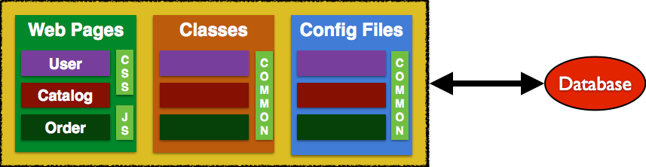

After 1 year customers love the product and the customers increased 100 times.

So added more servers to solve this problem and added database nodes to handle the traffic.

After implementing this realized that number of products browse people are more and purchase peoples is less. And Business needs new features are very high speed. So Again below problems came.

After adding new complex code to the monolithic application the new joiners will take more time to understand the code. And slower in development.

Number of issues reported by customer will increase. And deployment time also will increase. Lot of new dependency added by new developers.

So solution found that is micro services. Customer registration… service independently deployable and testable web service.

**Like below Example for Microservices.**

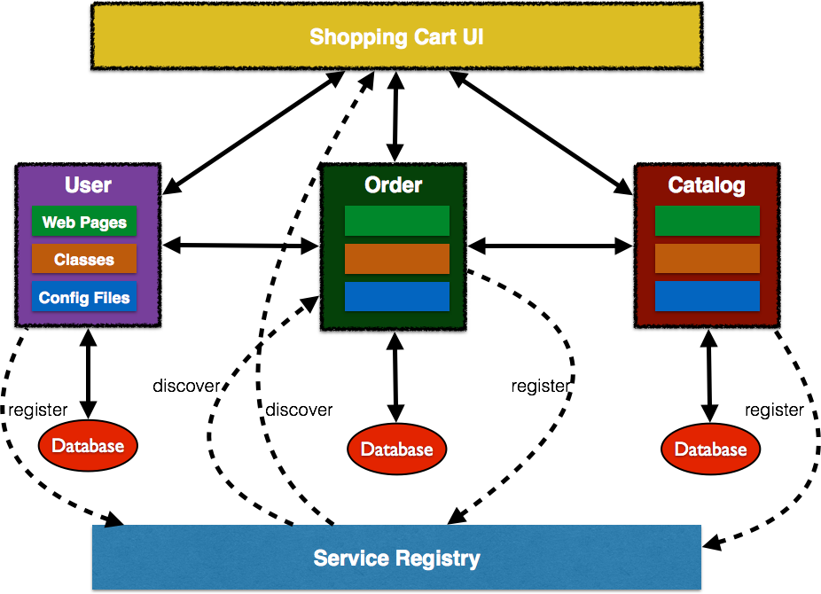

So decide to divide application into Microservices.

**Advantages**

Faster in responding customer complains

Very quick in building new features.

**Disadvantages**

Lot more communication between the teams and required standardized platforms.

**Point to Note**

For Communication Between one Microservices to another Microservices is we have below services.

|  |  |
| --- | --- |
| Communication | Implement ation |
| Synchronous | Rest Over Http Thrift |
| Asynchronous | KAFKA,ACTIVE MQ |

For maintaining Microservices in cloud. We have below Cloud Platforms.

* Amazon Web Services
* Azure
* Google Cloud
* HEROKU
* In House Services

Final conclusion if the application is small then goes with monolithic and if applications are big then goes with micro services.

**Java Rest Web Services Implementations.**

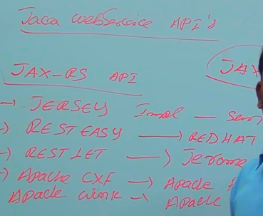

Spring Rest also implementation for JAX-RS